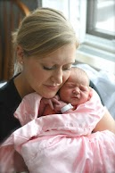



**LOOK**

**MAGAZINE**

Siblings’ First Impressions

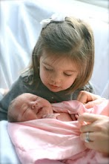

**Celebrating America – Baby’s First Photos Edition**